**Exercise 3: Stored Procedures**

**Scenario 1:** The bank needs to process monthly interest for all savings accounts.

* + **Question:** Write a stored procedure **ProcessMonthlyInterest** that calculates and updates the balance of all savings accounts by applying an interest rate of 1% to the current balance.

**Queries:**

CREATE TABLE Accounts (

AccountID NUMBER PRIMARY KEY,

CustomerID NUMBER,

Balance NUMBER,

AccountType VARCHAR2(20)

);

INSERT INTO Accounts VALUES (1, 101, 1000, 'SAVINGS');

INSERT INTO Accounts VALUES (2, 102, 2000, 'CURRENT');

INSERT INTO Accounts VALUES (3, 103, 3000, 'SAVINGS');

COMMIT;

**PL/SQL:**

CREATE OR REPLACE PROCEDURE ProcessMonthlyInterest IS

BEGIN

UPDATE Accounts

SET Balance = Balance + (Balance * 0.01)

WHERE AccountType = 'SAVINGS';

DBMS_OUTPUT.PUT_LINE('Monthly interest applied to all savings accounts.');

COMMIT;

END;

/

**Output:**

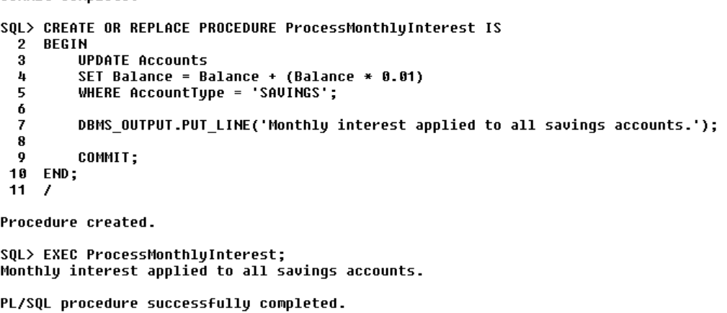

**Scenario 2:**

The bank wants to implement a bonus scheme for employees based on their performance.

* + **Question:** Write a stored procedure **UpdateEmployeeBonus** that updates the salary of employees in a given department by adding a bonus percentage passed as a parameter.

**Queries:**

CREATE TABLE Employees (

EmployeeID NUMBER PRIMARY KEY,

Name VARCHAR2(100),

Salary NUMBER,

DepartmentID NUMBER

);

INSERT INTO Employees VALUES (1, 'John Doe', 30000, 5);

INSERT INTO Employees VALUES (2, 'Jane Smith', 25000, 5);

INSERT INTO Employees VALUES (3, 'Michael Brown', 40000, 6);

COMMIT;

**PL/SQL :**

CREATE OR REPLACE PROCEDURE UpdateEmployeeBonus (

p_DepartmentID IN NUMBER,

p_BonusPercent IN NUMBER

) IS

BEGIN

UPDATE Employees

SET Salary = Salary + (Salary * (p_BonusPercent / 100))

WHERE DepartmentID = p_DepartmentID;

DBMS_OUTPUT.PUT_LINE('Bonus of ' || p_BonusPercent || '% applied to department ' || p_DepartmentID);

COMMIT;

END;

/

EXEC UpdateEmployeeBonus(5, 10);

**OutPut:**

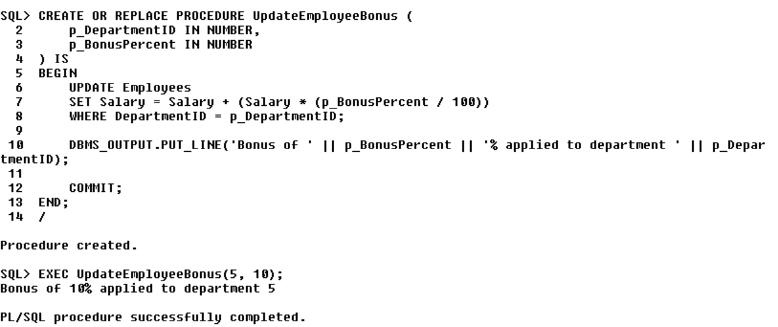

**Scenario 3:**

Customers should be able to transfer funds between their accounts.

* + **Question:** Write a stored procedure **TransferFunds** that transfers a specified amount from one account to another, checking that the source account has sufficient balance before making the transfer.

**PL/SQL:**

CREATE OR REPLACE PROCEDURE TransferFunds (

p_SourceAccountID IN NUMBER,

p_TargetAccountID IN NUMBER,

p_Amount IN NUMBER

) IS

v_SourceBalance NUMBER;

BEGIN

-- Check if source account exists and get its balance

SELECT Balance INTO v_SourceBalance

FROM Accounts

WHERE AccountID = p_SourceAccountID;

-- Check if balance is sufficient

IF v_SourceBalance >= p_Amount THEN

-- Deduct from source account

UPDATE Accounts

SET Balance = Balance - p_Amount

WHERE AccountID = p_SourceAccountID;

-- Add to target account

UPDATE Accounts

SET Balance = Balance + p_Amount

WHERE AccountID = p_TargetAccountID;

DBMS_OUTPUT.PUT_LINE('Transfer of ' || p_Amount || ' from Account ' || p_SourceAccountID || ' to Account ' || p_TargetAccountID || ' completed.');

COMMIT;

ELSE

DBMS_OUTPUT.PUT_LINE('Error: Insufficient balance in source account.');

END IF;

EXCEPTION

WHEN NO_DATA_FOUND THEN

DBMS_OUTPUT.PUT_LINE('Error: One or both account IDs do not exist.');

END;

/

EXEC TransferFunds(1, 2, 1000);

**OutPut:**

